EMAIL SIGNATURE GUIDELINES

Please adhere strictly to our corporate email signature setup. We are very particular about the colour and font style used.

- Font Type: Arial
- Colour: Black
- Size: 11

Digital 38

Best Regards,

Name Surname
Account Executive

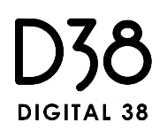
www.digital38.com
t: +65 xxxx xxxx m: +65 xxxx xxxx f: +65 6538 9937

